Vehicle Detection Write up

1. Histogram of Oriented Gradients (HOG)
   1. I extracted the HOG features in the function ‘get_hog_features’. I started by reading in all the vehicle and non-vehicle images. Here is an example of one of each class and their HOG features.

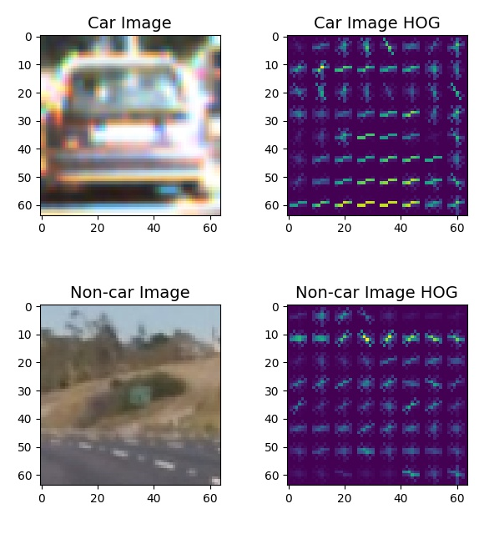

* 1. I settled on my final parameters by using what Udacity gave me in the lesson.
  2. I trained a linear classifier using the selected HOG features, spatial bin, and histogram of colors in the function “train_model”.

1. Sliding Window Search
   1. I implemented Sliding window search in the function ‘find_cars’. I only scanned the bottom portion of the image (because cars aren’t typically found in the sky). I also created a for loop and changed the scale at each iteration to sweep the image with large windows as well as smaller windows. The image below shows an example of the types of windows that I used. The windows only represent about 10% of the actual windows that I used.

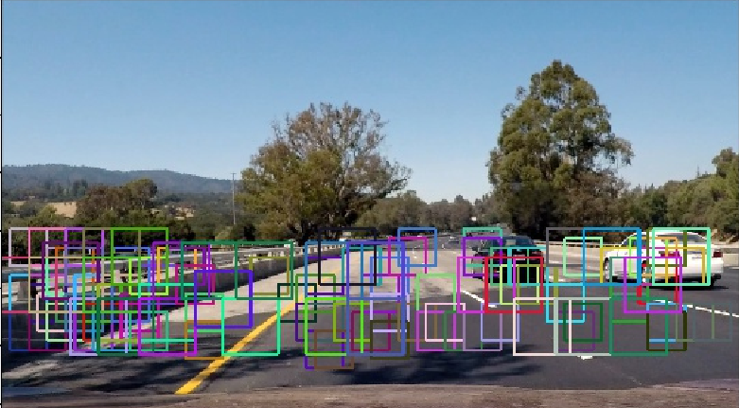

* 1. As mentioned before, I searched each window with HOG features, spatial bins, and histogram of colors. Here are my results:

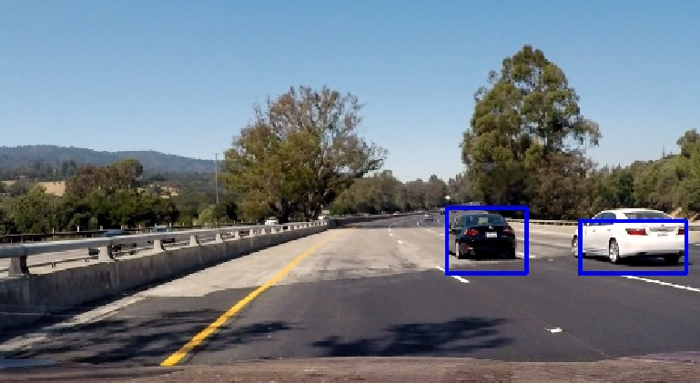

1. Video Implementation
   1. The video can be found in the Github repository.
   2. I recorded all of the windows with positive detections in an array called ‘hot_windows_find_cars’. I then created a heatmap and thresholded that map to identify vehicle positions. I constructed bounding boxes to cover the area of each blob detected. Here is an example of what the heat map looks like as well as the labeled images.

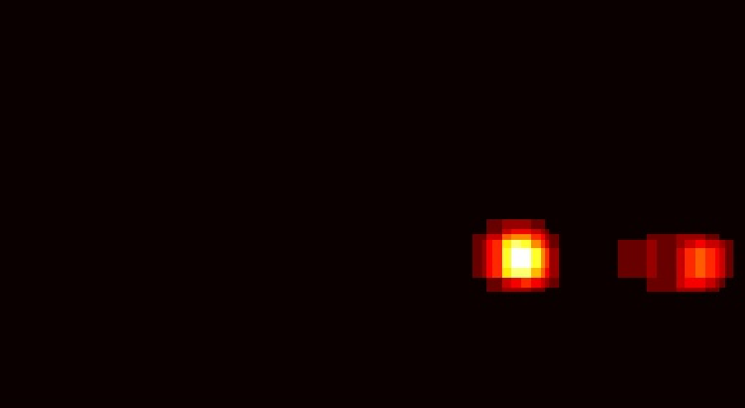

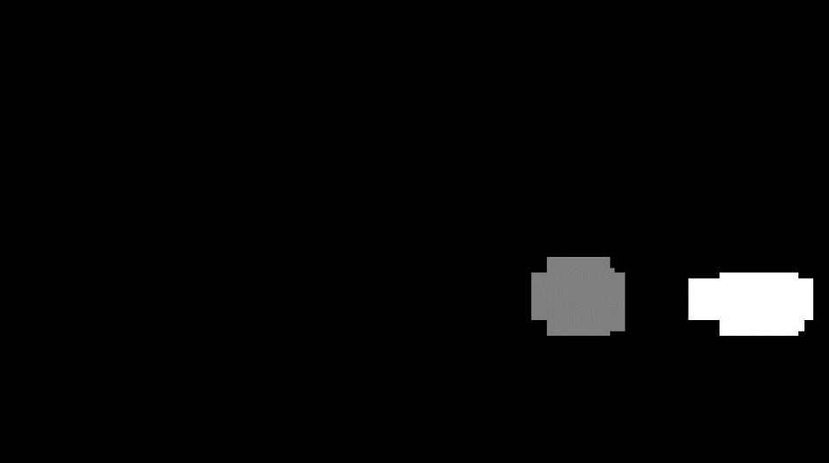

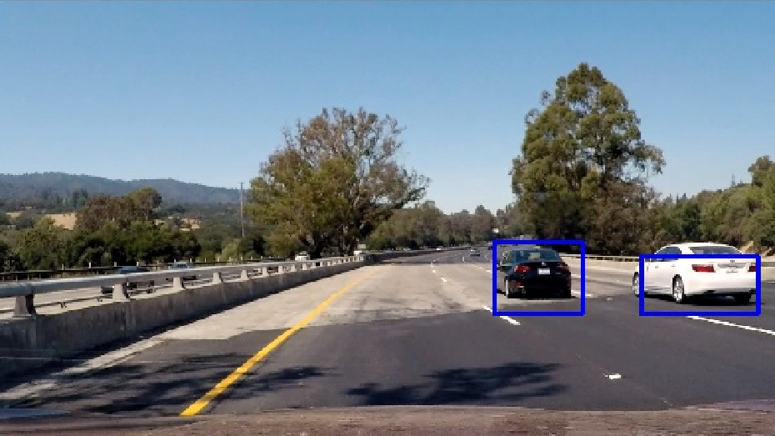

Discussion

I didn’t finely tune the parameters to extract my HOG features. This may cause my code to miss a car or create a false positive. I should also work on gathering historical data. Right now my code looks at each image individually. If I wanted to make it more robust, I should be keeping a record of where a known car is and track them. This way, I will greatly reduce the amount of false positive that I get because in the real world, cars don’t just pop up out of nowhere.